**17-11-2022 -18/11/2022**

**JavaScript**

JavaScript (js) is a light-weight object-oriented programming language which is used by several websites for scripting the webpages. JavaScript is not a compiled language, but it is a translated language. The JavaScript Translator (embedded in the browser) is responsible for translating the JavaScript code for the web browser.

Features of JavaScript

There are following features of JavaScript:

1. All popular web browsers support JavaScript as they provide built-in execution environments.
2. JavaScript follows the syntax and structure of the C programming language. Thus, it is a structured programming language.
3. JavaScript is a weakly typed language, where certain types are implicitly cast (depending on the operation).
4. JavaScript is an object-oriented programming language that uses prototypes rather than using classes for inheritance.
5. It is a light-weighted and interpreted language.
6. It is a case-sensitive language.
7. JavaScript is supportable in several operating systems including, Windows, macOS, etc.
8. It provides good control to the users over the web browsers.

Application of JavaScript

JavaScript is used to create interactive websites. It is mainly used for:

* Client-side validation,
* Dynamic drop-down menus,
* Displaying date and time,
* Displaying pop-up windows and dialog boxes (like an alert dialog box, confirm dialog box and prompt dialog box),
* Displaying clocks etc.

3 Places to put JavaScript code

1. Between the body tag of html
2. Between the head tag of html
3. In .js file (external javaScript)

## JavaScript Example: code between the body tag

<script type="text/javascript">

 alert("Hello Javatpoint");

</script>

## JavaScript Example : code between the head tag

<html>

<head>

<script type="text/javascript">

function msg(){

 alert("Hello Javatpoint");

}

</script>

</head>

<body>

<p>Welcome to JavaScript</p>

<form>

<input type="button" value="click" onclick="msg()"/>

</form>

</body>

</html>

# External JavaScript file

We can create external JavaScript file and embed it in many html page.

It provides **code re usability** because single JavaScript file can be used in several html pages.

An external JavaScript file must be saved by .js extension. It is recommended to embed all JavaScript files into a single file. It increases the speed of the webpage.

Let's create an external [JavaScript](https://www.javatpoint.com/javascript-tutorial) file that prints Hello Javatpoint in a alert dialog box.

message.js

function msg(){

 alert("Hello Javatpoint");

}

Index.html

<html>

<head>

<script type="text/javascript" src="message.js"></script>

</head>

<body>

<p>Welcome to JavaScript</p>

<form>

<input type="button" value="click" onclick="msg()"/>

</form>

</body>

</html>

# JavaScript Variable

A JavaScript variable is simply a name of storage location. There are two types of variables in JavaScript : local variable and global variable.

There are some rules while declaring a JavaScript variable (also known as identifiers).

1. Name must start with a letter (a to z or A to Z), underscore( _ ), or dollar( $ ) sign.
2. After first letter we can use digits (0 to 9), for example value1.
3. JavaScript variables are case sensitive, for example x and X are different variables.

var x = 10;

var _value="sonoo";

Local variable: A JavaScript local variable is declared inside block or function. It is accessible within the function or block only. For example:

## Global variable:A JavaScript global variable is accessible from any function. A variable i.e. declared outside the function or declared with window object is known as global variable.

# **JavaScript Functions**

**JavaScript functions** are used to perform operations. We can call JavaScript function many times to reuse the code.

#### **Advantage of JavaScript function**

There are mainly two advantages of JavaScript functions.

1. **Code reusability**: We can call a function several times so it save coding.
2. **Less coding**: It makes our program compact. We don’t need to write many lines of code each time to perform a common task.

JavaScript Function Syntax

The syntax of declaring function is given below.

1. function functionName([arg1, arg2, ...argN]){
2. //code to be executed
3. }

## JavaScript Function Object

In JavaScript, the purpose of **Function constructor** is to create a new Function object. It executes the code globally. However, if we call the constructor directly, a function is created dynamically but in an unsecured way.

## Syntax

1. new Function ([arg1[, arg2[, ....argn]],] functionBody)

## Parameter

**arg1, arg2, .... , argn** - It represents the argument used by function.

**functionBody** - It represents the function definition.

# **JavaScript Objects**

A javaScript object is an entity having state and behavior (properties and method). For example: car, pen, bike, chair, glass, keyboard, monitor etc.

JavaScript is an object-based language. Everything is an object in JavaScript.

JavaScript is template based not class based. Here, we don't create class to get the object. But, we direct create objects.

## Creating Objects in JavaScript

There are 3 ways to create objects.

1. By object literal
2. By creating instance of Object directly (using new keyword)
3. By using an object constructor (using new keyword)

## JavaScript Object by object literal

The syntax of creating object using object literal is given below:

1. object={property1:value1,property2:value2.....propertyN:valueN}

## property and value is separated by : (colon).

## 2) By creating instance of Object

The syntax of creating object directly is given below:

1. var objectname=new Object();

Here, **new keyword** is used to create object.

# **JavaScript Array**

**JavaScript array** is an object that represents a collection of similar type of elements.

There are 3 ways to construct array in JavaScript

1. By array literal
2. By creating instance of Array directly (using new keyword)
3. By using an Array constructor (using new keyword)

## JavaScript Array Methods

## push(),pop(),unshift(),shift(),isArray(),indexOf(),sort(),reverse()

# **JavaScript String**

The **JavaScript string** is an object that represents a sequence of characters.

There are 2 ways to create string in JavaScript

1. By string literal
2. By string object (using new keyword)

## JavaScript String Methods

Concat(),indexOf(),charAt(),search(),lastIndexOf(),substring(),replace()

# **Document Object Model**

The **document object** represents the whole html document.

When html document is loaded in the browser, it becomes a document object. It is the **root element** that represents the html document. It has properties and methods. By the help of document object, we can add dynamic content to our web page.

## Properties of document object

Let's see the properties of document object that can be accessed and modified by the document object. 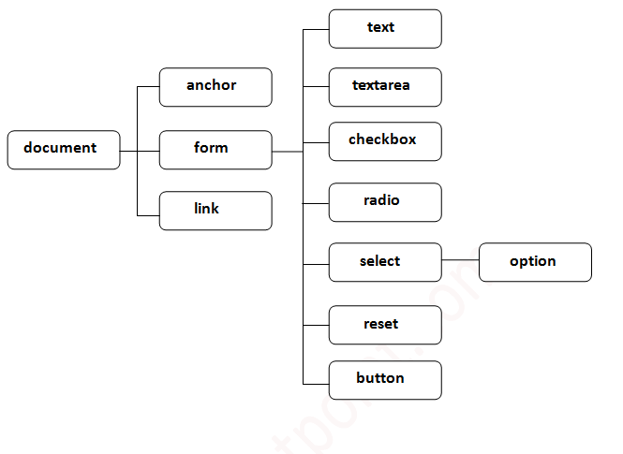

Methods of document object

We can access and change the contents of document by its methods.

The important methods of document object are as follows:

|  |  |
| --- | --- |
| **Method** | **Description** |
| write("string") | writes the given string on the doucment. |
| writeln("string") | writes the given string on the doucment with newline character at the end. |
| getElementById() | returns the element having the given id value. |
| getElementsByName() | returns all the elements having the given name value. |
| getElementsByTagName() | returns all the elements having the given tag name. |
| getElementsByClassName() | returns all the elements having the given class name. |